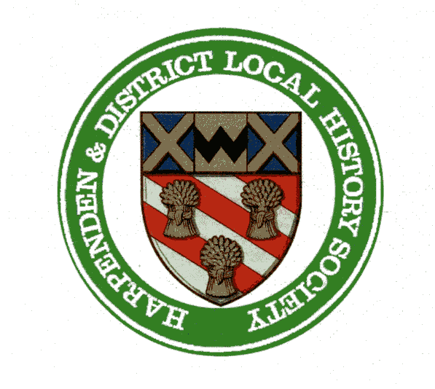

HARPENDEN & DISTRICT LOCAL HISTORY SOCIETY
Registered Charity no. 277169

Order Form

Name ………………………………………………..........................................

Address ……………………………………………..........................................

………………………………………………..........................................

………………………………………………..........................................

Post code ……………………….......

Email ………………………………………………..........................................

I wish to order ………. copy/ies of “The Story of Harpenden from Village to Town” at £3 per copy, plus 75p post and package each.

I enclose payment of ……................................ by cheque payable to “Harpenden & District Local History Society”,

or by BACS transfer to
HDLHS
Lloyds Bank
Account No. : 00052341
Sort Code: 30-93-90
Ref: Sales HS and your name

and send your order to:
Gavin Ross
21 Connaught Road
Harpenden AL5 4TW

To arrange to collect a copy, do phone 01582 715399

www.harpenden-history.org.uk

