Brief by Tom Lawrence for Ryck Lydekker read at the unveiling of the Roll of Honour at Pembroke School Nakuru, Kenya

John Ryke Wolfe Lydekker.
Born on 24th August 1921, the son of a District Commissioner John Wolfe Lydekker and his wife Clare. Ryke went to Pembroke House in April 1929 aged eight and was there for three years before his family returned to England in 1932. He joined the Navy in about 1936.
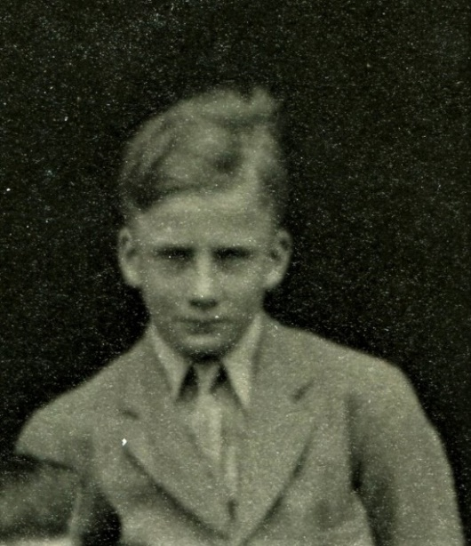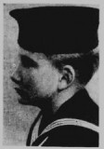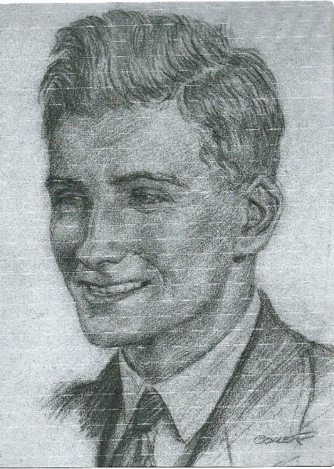
Ryke in 1934 Ryke in 1936 Ryke in c. 1940

At the outbreak of war, he was posted to the destroyer HMS Vortigern and saw service when the French fleet was attacked in the Algerian port of Oran. Whilst away on a short leave HMS Vortigern was sunk, and so joined the crew of HMS Quentin, and was involved in the sinking of enemy submarines, and then was in Battle of Skerki Bank in the Mediterranean when an Allied flotilla caught a convoy off guard in the early morning. They sank four troopships, and a destroyer, but HMS Quentin was torpedoed by aircraft and Ryke was Mentioned in Dispatches for his ‘…courage and zeal as the Navigating & Plotting Officer… during many successful engagements with the enemy, and in particular for his outstanding skill in an action with a U-boat which was sunk of Bone in November 1942’
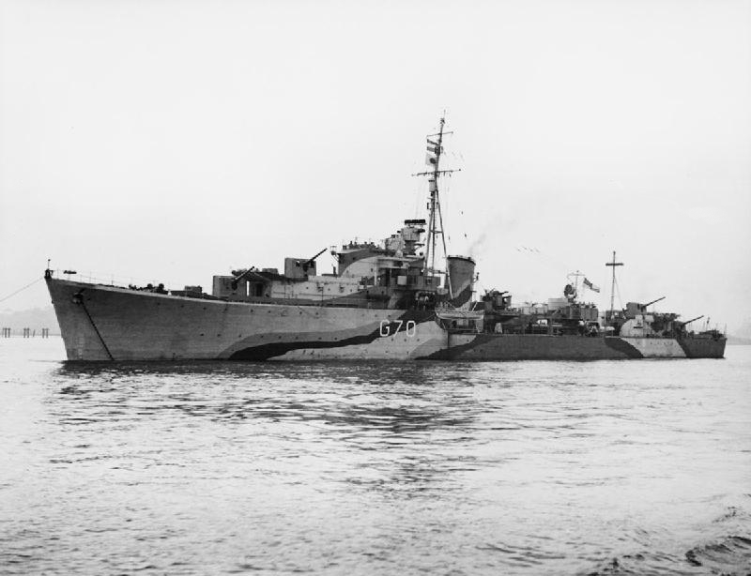
HMS Quentin

With the demise of HMS Quentin, he was ship-less and was bound for England reappears on the Canadian corvette HMCS Weyburn as a passenger. As part of Convoy MKS-8 running from Gibraltar. At 11:17 on 23rd Feb 1943 they hit a mine laid by the German submarine, U-118. Ryke immediately went to the bridge to assist where he could, and managed to get a lifeboat afloat that had had badly damaged launching gear. A Lieut. Milson was the last person the leave the ship, diving into the water and got to Lydekker’s boat. It became immediately apparent that the Captain was still on the bridge, and Lydekker dived in to get him. As he got close to the ship it began to sink by the stern, and as it did so, there was a tremendous explosion from the two still-primed depth charges. He was not seen again.
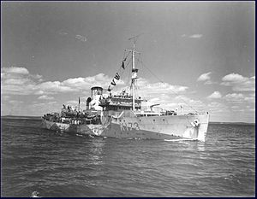
HMS Weyburn

